Stepper Motors for Primary Arm Control

Thomas Bock

Lab Partners

Vyacheslav Chiley

Daniel Komac

Anastasiya Herasimava

EEE174

Lab 7

Dennis Dahlquist

Kristopher Moyer

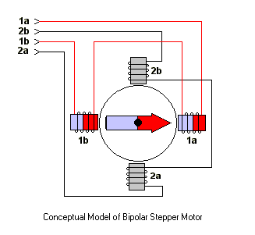For this project I wanted to learn more about how a stepper motor works and the differences of a stepper motor compared to a DC motor or servo motor. Stepper motors are primarily used in CNC machines, 3d Printers and other industrial applications, where precision and repeatability are important. Here is the type of servo I used for the experiment:

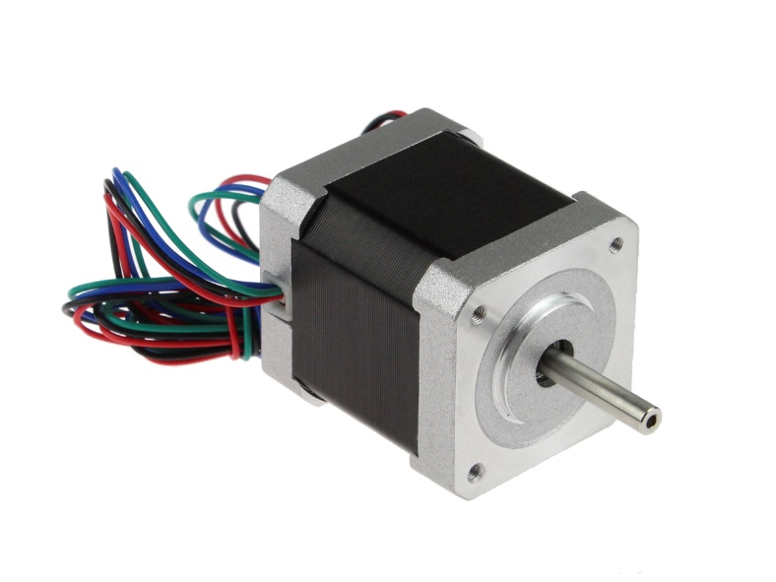

It is a NEMA 17, 4 wire, bipolar stepper motor. The stepper is wired with opposing inductors that cause the motor to “step” when energized. Alternating the energizing of the inductors causes the stepper motor shaft to rotate. Standard stepper motors have a 1.8\* rotation per step. This can be further improved by using a stepper motor driver that allows microstepping.

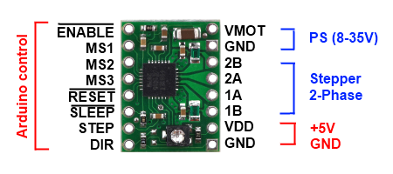 A stepper motor driver is usually required to power a stepper motor, due to the complicated nature of making the stepper rotate, and the current that is required to operate the motor. Stepper motors of this size can use up to two amps of current. The control of the stepper motor is simplified due to the driver taking the 4 wires of the stepper motor for output, and only requiring an input pin to step the motor, a pin determining direction, and a pic to enable the motor. A stepper motor driver is shown below.

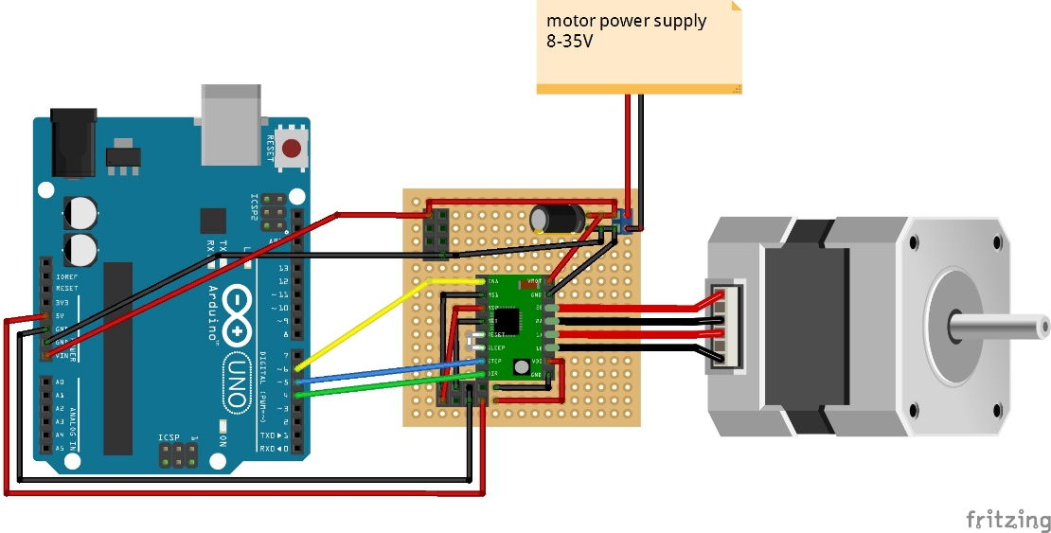 The following circuit was used:

T

The program code to test out the stepper motor is as follows:

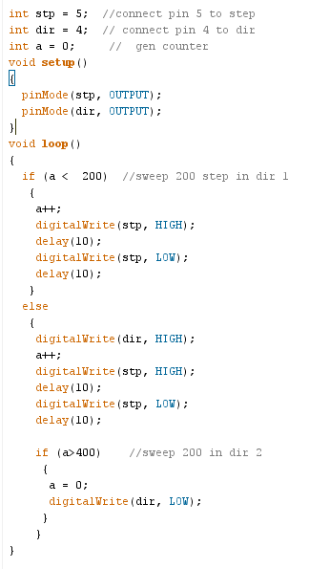

The testing of the stepper motor in this environment was successful with minimal problems. The concerns with this type of control of the stepper is that it does not included any type of acceleration and very minimal speed control. When it comes to the steppers inside the robotic arm, the weight or the arm and the friction of all the joints could become problematic. I will look for some Arduino libraries that allow for acceleration.